|  |  |
| --- | --- |
| Last updated | 24/02/2023 |
| Author | Adrian Poole | Team Leader – Product Developer |
| Description | Documentation on the configuration of Councillor casework workflow |

Councillor casework  
Workflow configuration

Use this guide to learn more about how to configure the Councillor casework workflow on GovService.

In this document

Permissions 2

Integrations 3

Workflow 3

# Permissions

You do not have the ability to export permissions or permission groups from the GovService platform like you can workflows and integrations, so you will need to set this up manually.

Following best practices, the below diagram shows how the permission groups should be setup in the **Permissions Manager**.

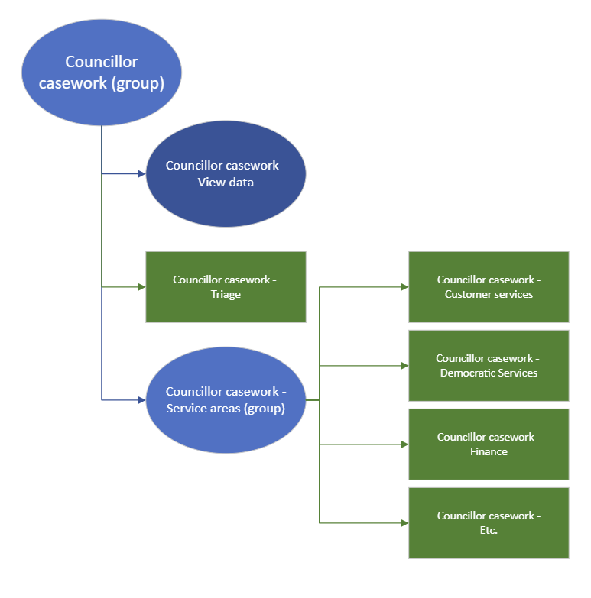

Where you see **(groups)**, this permission should not contain any users directly and is purely for providing structure to the permissions.

When building the CaseViewer views for officers to use, you may wish to set the view against the top **Councillor casework (group)** parent permission group, as this will enable to view on CaseViewer for users that belong to any of the child groups.

There is an additional permission group called **Councillors** that is assigned to Councillor accounts. This may have already been setup as part of implementation. This is kept outside and separate from the above **Councillor casework (group)**.

# Integrations

Prior to importing the workflow JSON file, you **must** first import the integrations associated with the workflow through the **Integrations Manager**.

After the import, you will need to go through each of them to update branding and wording, and update LIM and systems set in the integrations (which will likely be blank after the import).

|  |
| --- |
| The import should automatically categorise the integrations under **Councillor casework** in the Integrations Manager. |

# Workflow

Once you have completed your Permissions setup and Integrations import, you can now import the workflow JSON file. Provided you have completed the earlier steps, the imported workflow will have the integrations already attached to the relevant stages and setup with the relevant conditions.

You can then add the relevant permission groups to the workflow. For example, setting:

* the workflow’s View data group to **Councillor casework – View data** permission group
* the static assigned group for the Triage stage to the **Councillor casework – Triage** permission group
* the hidden form logic that controls assignment based on permission USERGROUP IDs to match the ones you’ve created

|  |
| --- |
| Depending on the services that your Council provides, you will need to update the form categories and service types that the Councillor can select within their initial **Crease casework** form, and any associated logic for this. |